**Species are in limited supply**

**Call the “sold out” number: 970-491-8278 before ordering, or visit:** <http://www.colostate.edu/Depts/CSFS/inventory.pdf>

**Return Order Forms To:**

Routt County Conservation District

1475 Pine Grove Rd. -Ste. 201A

Steamboat Springs, CO 80487

*Phone: 970.879.3225 ext. 107*

*Fax: 970.879.2517*

*morgan.moss@routtcountycd.com*

**2014 Tree Seedling Order Form**

Application for Seedling Trees

Name: ________________________________Mailing Address:_________________________

City: __________________________State:______ Zip: ______ Phone #: ________________

County: _______________ Email: _____________________

**Payment Options – Order will not be submitted until payment is received.**

**Check that which applies:**

* **Check -** Make checks payable and return to: Routt County Conservation District, 1475 Pine Grove Rd.-Ste. 201A, Steamboat Springs, Colorado 80487 (mail in or drop off in person).
* **Cash -** Return to: Routt County Conservation District, 1475 Pine Grove Rd.-Ste. 201A, Steamboat Springs, Colorado 80487 (drop off in person).

**Delivery Options:**

**All seedling orders made through the Routt County Conservation District must be picked up on delivery day in Steamboat Springs. Delivery day is expected to be sometime in mid-May, 2014. Exact date and pick-up location will appear on the RCCD website once confirmed (**[**www.routtcountycd.com**](http://www.routtcountycd.com)**).**

**\*No UPS orders can be made through the Routt County Conservation District.**

|  |  |  |  |  |  |  |
| --- | --- | --- | --- | --- | --- | --- |
| **Bare Root Trees -** lots of 25 per species ($1.08/seedling)  DECIDUOUS: 10”-30” top height, CONIFER: 5”-12” top height | | | | | | |
| **#** | **Species Name** | | **#of Lots/Price** | | | **Subtotal** |
| 001 | Caragana | |  | 27.00 | |  |
| 002 | Cotoneaster | |  | 27.00 | |  |
| 004 | |  | | --- | | Chokecherry | | |  | 27.00 | |  |
| 006 | |  | | --- | | Native Plum | | |  | 27.00 | |  |
| 007 | |  | | --- | | Sumac (Skunkbush) | | |  | 27.00 | |  |
| 009 | Nanking Cherry | |  | 27.00 | |  |
| 012 | Buffaloberry | |  | 27.00 | |  |
| 017 | |  | | --- | | Red Osier Dogwood | | |  | 27.00 | |  |
| 018 | N M Privet (Forestiera) | |  | 27.00 | |  |
| 019 | Wax Currant | |  | 27.00 | |  |
| 022 | |  | | --- | | Hybrid Cottonwood | | |  | 27.00 | |  |
| 023 | |  | | --- | | Mixed Willow | | |  | 27.00 | |  |
| 024 | Golden Willow | |  | 27.00 | |  |
| 026 | Honeylocust | |  | 27.00 | |  |
| 027 | |  | | --- | | Lanceleaf Cottonwood | | |  | 27.00 | |  |
| 030 | |  | | --- | | Bur Oak | | |  | 27.00 | |  |
| 032 | |  | | --- | | Coyote Willow | | |  | 27.00 | |  |
| 034 | Peachleaf Willow | |  | 27.00 | |  |
| 035 | |  | | --- | | Prairie Sky Poplar | | |  | 27.00 | |  |
| 036 | |  | | --- | | Kremmling Cottonwood | | |  | 27.00 | |  |
| 102 | |  | | --- | | Eastern Redcedar | | |  | 27.00 | |  |
| 103 | |  | | --- | | Ponderosa Pine | | |  | 27.00 | |  |
| 104 | |  | | --- | | Rocky Mountain Juniper | | |  | 27.00 | |  |
| **Bare Roots Total:** | | | | | | |
| **Large Tubes -** lots of 30 per species ($2.57/seedling)  5”-12” top height | | | | | | |
| **#** | **Species Name** | **#of Lots/Price** | | | **Subtotal** | |
| 201 | |  | | --- | | Austrian Pine | |  | | 77.00 |  | |
| 202 | |  | | --- | | Colorado Blue Spruce | |  | | 77.00 |  | |
| 203 | |  | | --- | | Douglas Fir | |  | | 77.00 |  | |
| 204 | |  | | --- | | Engelmann Spruce | |  | | 77.00 |  | |
| 207 | |  | | --- | | Pinon Pine | |  | | 77.00 |  | |
| 208 | |  | | --- | | Ponderosa Pine | |  | | 77.00 |  | |
| 209 | |  | | --- | | Rocky Mountain Juniper | |  | | 77.00 |  | |
| 212 | |  | | --- | | Bristlecone Pine | |  | | 77.00 |  | |
| 217 | |  | | --- | | Black Hills Spruce | |  | | 77.00 |  | |
| 219 | |  | | --- | | Four Wing Saltbush | |  | | 77.00 |  | |
| 221 | |  | | --- | | Thinleaf Alder | |  | | 77.00 |  | |
| 222 | |  | | --- | | Antelope Bitterbrush | |  | | 77.00 |  | |
| 223 | |  | | --- | | Mountain Mahogany | |  | | 77.00 |  | |
| **Large Tubes Total:** | | | | | | |
| **Large Cell Styrofoam -** lots of 30/species ($2.57/seedling) | | | | | | |
| **#** | **Species Name** | **# of Lots/Price** | | | **Subtotal** | |
| 200 | Aspen |  | | 77.00 |  | |
| 213 | Narrowleaf Cottonwood |  | | 77.00 |  | |
| 218 | Fremont Cottonwood |  | | 77.00 |  | |
| 216 | Coyote Willow |  | | 77.00 |  | |
| **Large Cell Styrofoam Total:** | | | | | | |

**Routt County Conservation District Order Form**

**Visit our website at:**

**www.routtcountycd.com**

ORDER No._____________  
for Internal Use

|  |  |  |  |  |  |
| --- | --- | --- | --- | --- | --- |
| **Small Tubes -** lots of 30 per species ($2.20/seedling)  3”-6” top height | | | | | |
| **#** | **Species Name** | **#of Lots/Price** | | | **Subtotal** |
| 300 | Austrian Pine |  | 66.00 | |  |
| 302 | Douglas Fir |  | 66.00 | |  |
| 303 | Engelmann Spruce |  | 66.00 | |  |
| 304 | Lodgepole Pine |  | 66.00 | |  |
| 305 | Ponderosa Pine |  | 66.00 | |  |
| 307 | White Fir |  | 66.00 | |  |
| 310 | Rocky Mtn. Juniper |  | 66.00 | |  |
| 311 | Pinon Pine |  | 66.00 | |  |
| 321 | Bristlecone Pine |  | 66.00 | |  |
| 323 | Thinleaf Alder |  | 66.00 | |  |
| **Small Tubes Total:** | | | | | |
| **Trays Of 50 -** ($1.82/seedling) | | | | | |
| **#** | **Species Name** | **# of Lots/Price** | | | **Subtotal** |
| 600 | Austrian Pine |  | 91.00 | |  |
| 601 | Colorado Blue Spruce |  | 91.00 | |  |
| 602 | Douglas Fir |  | 91.00 | |  |
| 603 | Engelmann Spruce |  | 91.00 | |  |
| 604 | Lodgepole Pine |  | 91.00 | |  |
| 607 | White Fir |  | 91.00 | |  |
| 609 | Eastern Redcedar |  | 91.00 | |  |
| 610 | Rocky Mtn. Juniper |  | 91.00 | |  |
| 611 | Pinon Pine |  | 91.00 | |  |
| 621 | Bristlecone Pine |  | 91.00 | |  |
| 623 | Thinleaf Alder |  | 91.00 | |  |
| 625 | Black Hills Spruce |  | 91.00 | |  |
| 626 | Limber Pine |  | 91.00 | |  |
| **Trays Total:** | | | | | |
| **Extra Large Potted -** Boxes of 4 (11.00/seedling)  Approx. 1’-2’ Top Height | | | | | |
| **#** | **Species Name** | **# of Lots/Price** | | | **Subtotal** |
| 400 | Austrian Pine |  | 44.00 | |  |
| 401 | Colorado Blue Spruce |  | 44.00 | |  |
| 402 | Eastern Redcedar |  | 44.00 | |  |
| 408 | Ponderosa Pine |  | 44.00 | |  |
| 410 | Rocky Mtn. Juniper |  | 44.00 | |  |
| **\*RCCD has surplus of #401 and #408, please call 970.879.3225 ext. 107 for availability.**  **Extra Large Potted Total :** | | | | | |
| ***Totals:*** | | | | *$* | |
| **Add sales tax of 3.9% of total cost to all orders** | | | | *$* | |
| **TOTAL AMOUNT DUE** | | | | *$* | |

**CONDITIONS OF SALE**

1. **This nursery stock must be used for**

**conservation purposes only.**

2. Bareroot seedlings are available in multiples of

25 per species only.

3. Containerized seedlings are available in multiples

of 30 or 50 per species only, depending on

container type. Extra-large potted seedlings are

available in multiples of 4.

4. Payment must accompany order. **No**

**cancellations, or refunds can be made.**

5. There are no guarantees for seedling survival.

6. If trees ordered are not available, a refund may

be issued, unless a substitution is requested.

**“I HAVE READ AND AGREE WITH THE ABOVE “CONDITIONS OF SALE”**

Signature and date Required______________________________

THE COLORADO PROGRAM

The Colorado State Forest Service tree program enables landowners to obtain trees at nominal cost. The program’s aim is to encourage landowners to plant new forests; establish effective windbreaks to reduce erosion, protect homes, cropland, livestock and highways; and enhance wildlife habitat. Our trees and shrubs are grown for their conservation benefits. Ornamental qualities such as color, degree of flowering, fruit production and others are not guaranteed.

Contact your local nursery for ornamental needs.

PLAN BEFORE YOU PLANT

For planting plan assistance, contact your County Extension Agent, Natural Resource Conservation District, or Colorado State Forest District office. These offices can provide information on windbreak planning, tree planting and care.

*This nursery stock is produced and distributed by*

*the Colorado State Forest Service Nursery*

*All CSFS programs are offered on a non-discriminatory basis, without regard to race, color, national origin, religion, sex, marital status, or handicap.*

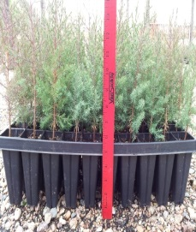_____________________________

**Small Trays**

* 21” x 11” x 6”
* Sold in trays of 50

**Individual tube size**

* 5” x 2”
* 190ml. each

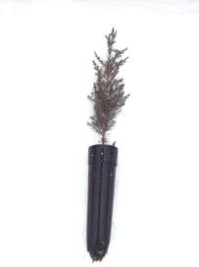

**Large Tubes**

* Sold in boxes of 30

**Individual tube size**

* 7” x 2”
* 262ml. each

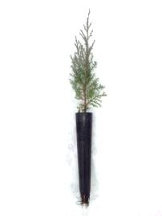

**Small Tubes**

* Sold in boxes of 30

**Individual tube size**

* 8” x 1.5”
* 164ml. each

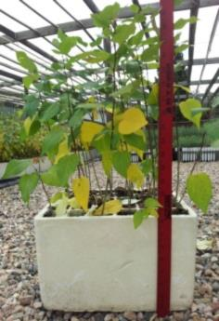

**Styro Containers**

* Sold in containers of 30 seedlings
* 14” x 11.5” x 8”
* Aspen, Cotton-woods, Willows

**Individual tube size**

* 8” x 2”
* 459ml. each

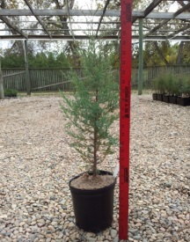

**Extra Large Pot**

* Sold in boxes of 4

**Individual tube size**

* 6” x 6.5”
* 2.84L. each

Questions about seedlings please visit: <http://csfs.colostate.edu/pages/seedling-tree-nursery.html>

Routt County Conservation District

1475 Pine Grove Road-Suite 201A

Steamboat Springs, CO 80487



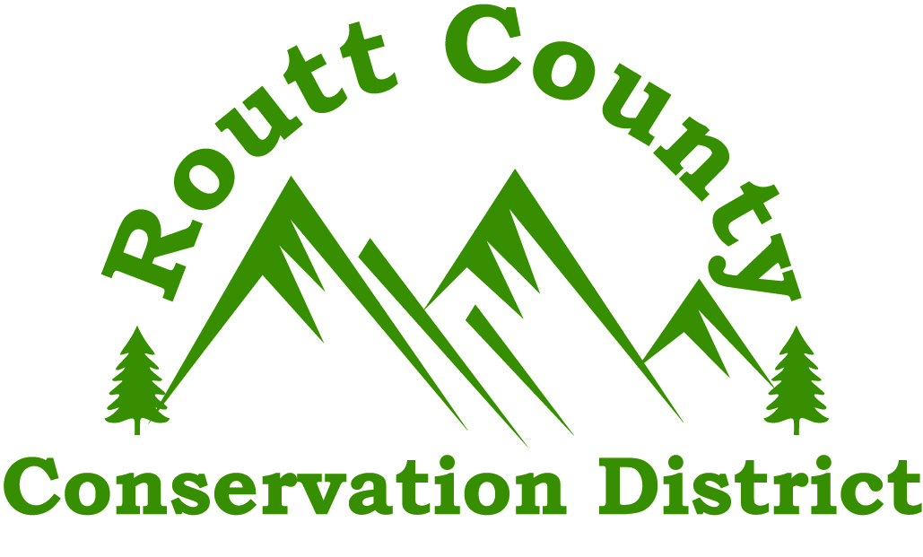

**SEEDLING PROGRAM**

**Nursery Order Form**

**2014**

The trees we plant now are trees that grow with our children.

• Reforestation

• Soil Health

• Windbreaks

• Wildlife Habitat

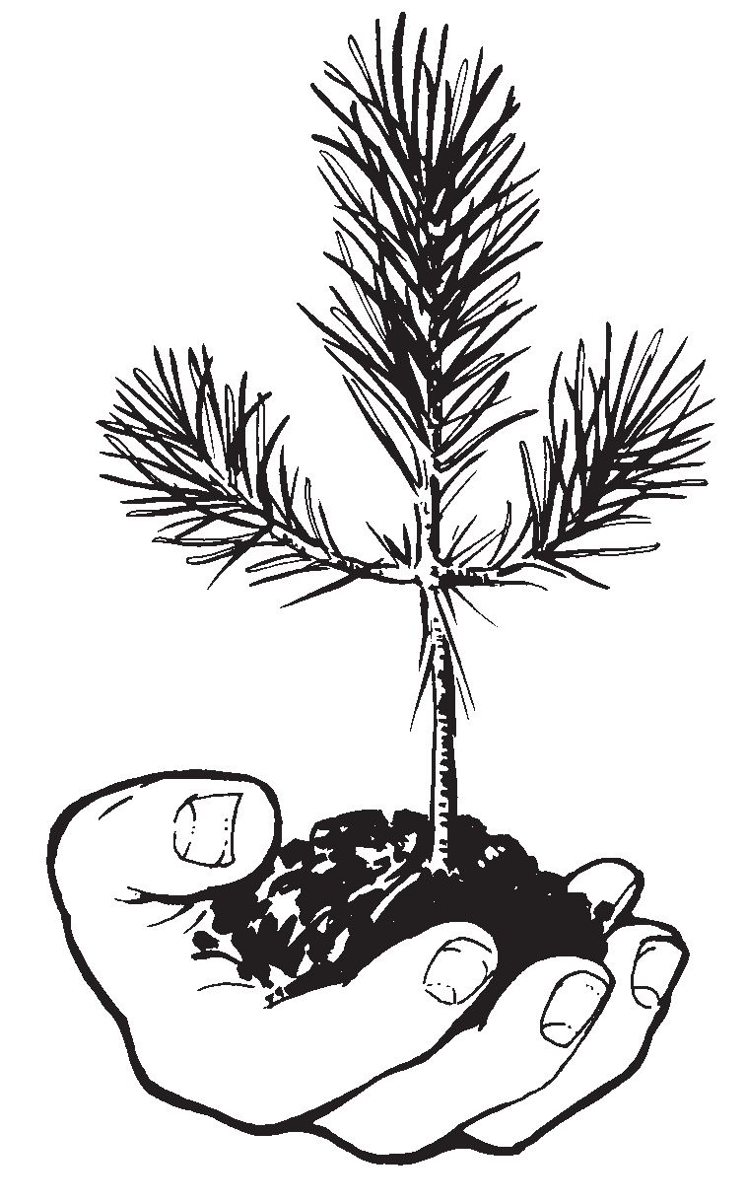

[***www.csfs.colostate.edu***](http://www.csfs.colostate.edu)

[***www.routtcountycd.com***](http://www.routtcountycd.com)